Press release
April 2024

Red Dot Award 2024 for Smaila from Weinor
The compact cubic awning scores again

The cubic awning Smaila from Weinor has already won the German Design Award 2024. Now, it has also been accoladed with the renowned Red Dot Award: for product design.
This again gives the sun and weather protection expert Weinor cause for joy. The compact cubic cassette awning Smaila for balconies and small patios has now also won the renowned Red Dot Award 2024: for product design.
Both design awards once again confirm Weinor’s high level of design competence. With it, the Red Dot Award jury, consisting of renowned experts, evaluated aspects such as design, quality and innovative strength.
High resilience and a large number of design versions
With its linear, compact cassette and high-quality technology, Smaila was able to score with the jury. Also, the Weinor LongLife arm and wind lock safety device ensure the best possible load capacity and durability and made a positive impression.
Decorative side panels and a choice of more than 200 frame colours and 170 fabric patterns convinced with ample design diversity. Optional features such as the atmospheric LED lighting or solar-powered vertical sun protection Valance Plus provide even better comfort on the patio or balcony.
The Red Dot Award is one of the most widely recognised design prizes worldwide and distinguishes superlative performance in the field of design.

Weinor media contact:
Christian Pätz
Weinor GmbH & Co. KG || Mathias-Brüggen-Str. 110 || D-50829 Köln
E-mail: cpaetz@weinor.de || weinor.com

Image material:
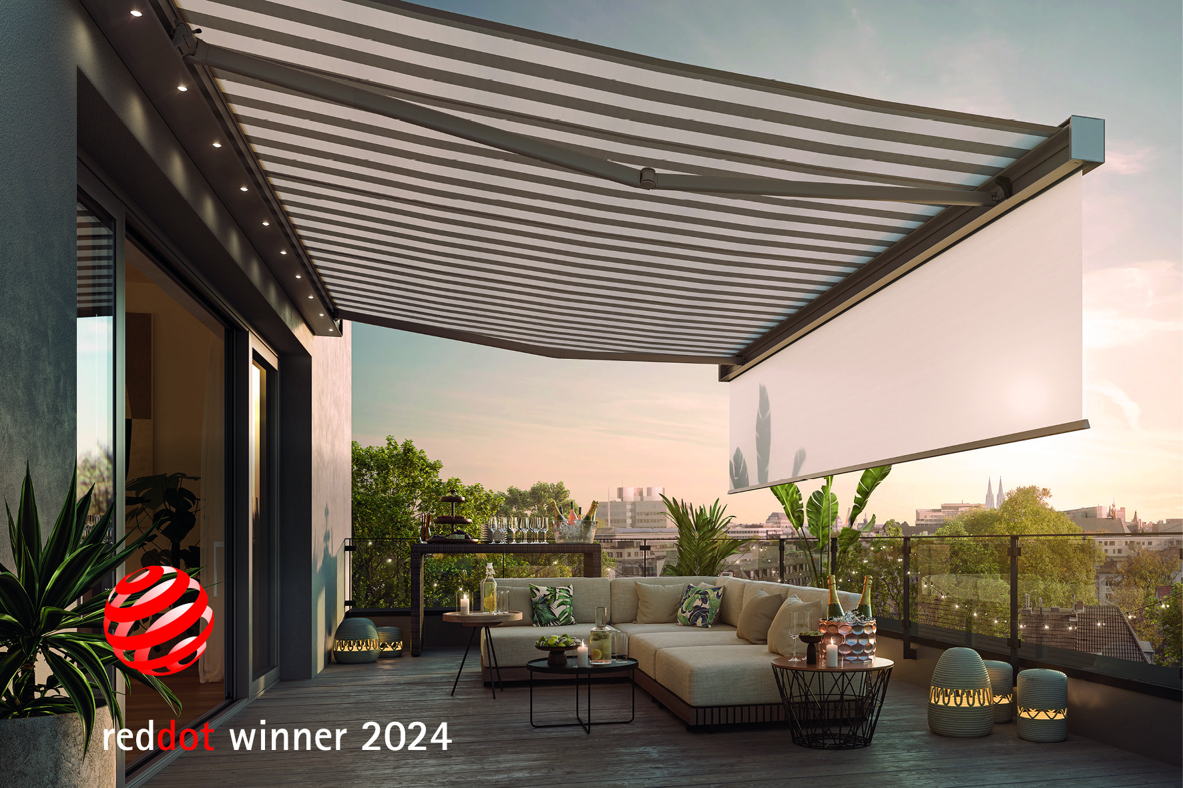
Picture:
The compact, cubic cassette awning Smaila has received the Red Dot Award 2024: for product design.

Photo: Weinor GmbH & Co. KG

